**Project 5 – Problem and Description**

For this assignment I created a vector of Student Records from a file (1). I then displayed the student records and test scores (2), and then used a quicksort function to sort the student information (3) and then displayed the student information (4).

1. For the first portion of the assignment I read information in from a file using a loop and then pushed each individual structure into a vector of structs:

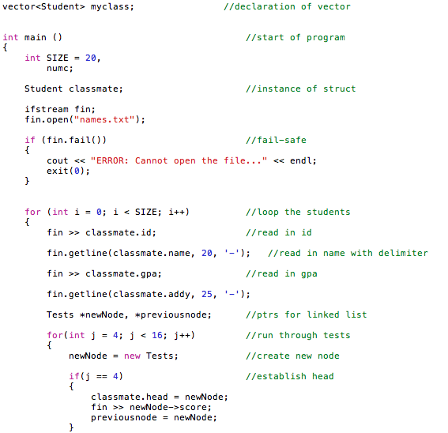

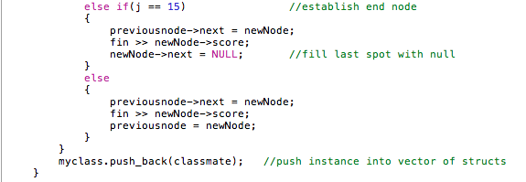

1. I displayed the student records – looping thorugh each student and each field of information:

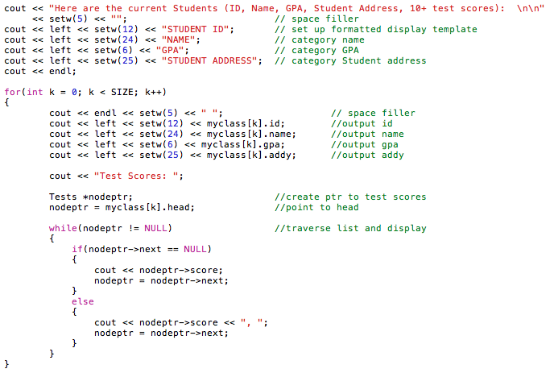

1. I created a quicksort function to sort the Student information. This was accomplished by determining a pivot point and then sorting each list to the left and right of that pivot point. To sort the list I recursively called the quick sort function:

Screen Shot 2014-05-04 at 7.05.59 PM.png

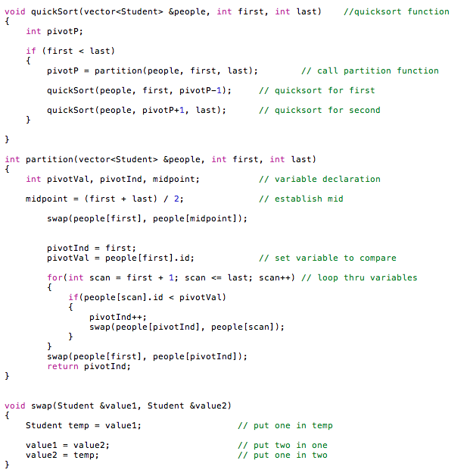

1. Lastly I displayed the sorted list:

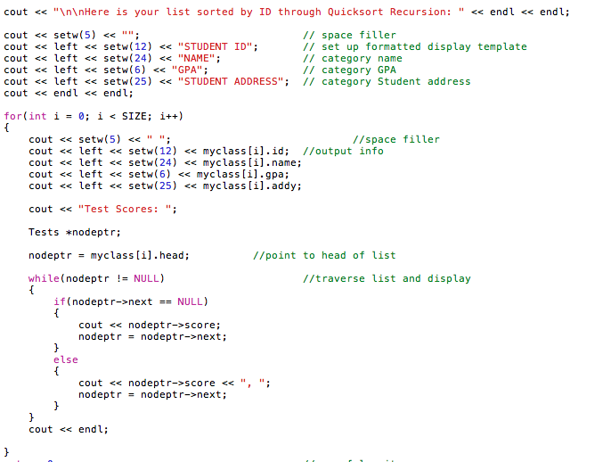

**Test Input and Output**

Here are the current Students (ID, Name, GPA, Student Address, 10+ test scores):

STUDENT ID NAME GPA STUDENT ADDRESS

33454444 Mike Stiller 3.75 221 Blue St. Test Scores: 99, 91, 83, 92, 94, 92, 97, 94, 93, 78, 66, 77

69988963 Marcy Eckhert 2.43 953 Ridgeway Rd. Test Scores: 77, 89, 63, 74, 85, 90, 93, 74, 85, 74, 73, 83

47763329 Lyndon Johnson 3.45 802 Love Ln. Test Scores: 99, 91, 83, 92, 94, 92, 97, 94, 93, 78, 83, 73

55584739 Wes Thompson 2.24 839 Hollow Tr. Test Scores: 92, 93, 74, 85, 74, 99, 91, 83, 92, 77, 83, 73

13453329 Alex Cortez 3.53 109 Crest St. Test Scores: 99, 91, 83, 92, 94, 92, 97, 94, 93, 78, 88, 93

45553894 Ben Lyons 3.34 220 Ridge Rd. Test Scores: 88, 92, 83, 27, 94, 93, 92, 94, 94, 92, 73, 83

59860454 Jimmy Woods 3.77 234 Orange St. Test Scores: 99, 91, 83, 92, 94, 92, 97, 94, 93, 78, 83, 94

38889643 Christie Mickey 3.45 552 Nickel Rd. Test Scores: 77, 89, 93, 74, 85, 92, 93, 74, 85, 74, 47, 85

59988963 Stella Esquire 3.33 9595 Colby Rd. Test Scores: 77, 89, 93, 74, 85, 92, 93, 74, 85, 74, 83, 93

61111339 Joey Gerald 2.46 1393 Mustang Tr. Test Scores: 57, 38, 88, 22, 76, 73, 99, 91, 83, 92, 83, 94

23897939 Ash Catchum 3.44 1550 Sagewood Tr. Test Scores: 92, 93, 74, 85, 74, 99, 91, 83, 92, 77, 73, 98

32498887 Caleb Nesbit 3.33 200 Peach Rd. Test Scores: 88, 92, 83, 27, 94, 93, 92, 94, 94, 92, 88, 77

66644324 Jackie Wild 2.74 134 Yellow St. Test Scores: 99, 91, 83, 92, 66, 92, 37, 94, 83, 78, 83, 74

57688874 Ricky Bobby 3.23 1776 Apple Ln. Test Scores: 88, 92, 83, 27, 94, 93, 92, 94, 94, 92, 73, 83

12493894 Ryan Marsh 3.23 220 River Rd. Test Scores: 88, 92, 83, 27, 94, 93, 92, 94, 94, 92, 99, 93

71771132 Michael Batson 1.46 1223 Lina Tr. Test Scores: 57, 38, 88, 66, 74, 73, 44, 91, 89, 92, 83, 94

52347499 Lexi Ryan 2.4 729 Wave Rd. Test Scores: 77, 89, 93, 74, 85, 92, 93, 74, 85, 74, 83, 73

20829499 Beth Marie 3.03 110 Copper Rd. Test Scores: 77, 89, 93, 74, 85, 92, 93, 74, 85, 74, 92, 45

44445939 Ashley Amigo 2.36 119 Sage Tr. Test Scores: 57, 38, 88, 22, 76, 73, 99, 91, 83, 92, 88, 94

75779329 Charlie Kowalski 4 919 Prarie Tr. Test Scores: 97, 98, 88, 22, 79, 73, 99, 91, 83, 92, 84, 93

Here is your list sorted by ID through Quicksort Recursion:

STUDENT ID NAME GPA STUDENT ADDRESS

12493894 Ryan Marsh 3.23 220 River Rd. Test Scores: 88, 92, 83, 27, 94, 93, 92, 94, 94, 92, 99, 93

13453329 Alex Cortez 3.53 109 Crest St. Test Scores: 99, 91, 83, 92, 94, 92, 97, 94, 93, 78, 88, 93

20829499 Beth Marie 3.03 110 Copper Rd. Test Scores: 77, 89, 93, 74, 85, 92, 93, 74, 85, 74, 92, 45

23897939 Ash Catchum 3.44 1550 Sagewood Tr. Test Scores: 92, 93, 74, 85, 74, 99, 91, 83, 92, 77, 73, 98

32498887 Caleb Nesbit 3.33 200 Peach Rd. Test Scores: 88, 92, 83, 27, 94, 93, 92, 94, 94, 92, 88, 77

33454444 Mike Stiller 3.75 221 Blue St. Test Scores: 99, 91, 83, 92, 94, 92, 97, 94, 93, 78, 66, 77

38889643 Christie Mickey 3.45 552 Nickel Rd. Test Scores: 77, 89, 93, 74, 85, 92, 93, 74, 85, 74, 47, 85

44445939 Ashley Amigo 2.36 119 Sage Tr. Test Scores: 57, 38, 88, 22, 76, 73, 99, 91, 83, 92, 88, 94

45553894 Ben Lyons 3.34 220 Ridge Rd. Test Scores: 88, 92, 83, 27, 94, 93, 92, 94, 94, 92, 73, 83

47763329 Lyndon Johnson 3.45 802 Love Ln. Test Scores: 99, 91, 83, 92, 94, 92, 97, 94, 93, 78, 83, 73

52347499 Lexi Ryan 2.4 729 Wave Rd. Test Scores: 77, 89, 93, 74, 85, 92, 93, 74, 85, 74, 83, 73

55584739 Wes Thompson 2.24 839 Hollow Tr. Test Scores: 92, 93, 74, 85, 74, 99, 91, 83, 92, 77, 83, 73

57688874 Ricky Bobby 3.23 1776 Apple Ln. Test Scores: 88, 92, 83, 27, 94, 93, 92, 94, 94, 92, 73, 83

59860454 Jimmy Woods 3.77 234 Orange St. Test Scores: 99, 91, 83, 92, 94, 92, 97, 94, 93, 78, 83, 94

59988963 Stella Esquire 3.33 9595 Colby Rd. Test Scores: 77, 89, 93, 74, 85, 92, 93, 74, 85, 74, 83, 93

61111339 Joey Gerald 2.46 1393 Mustang Tr. Test Scores: 57, 38, 88, 22, 76, 73, 99, 91, 83, 92, 83, 94

66644324 Jackie Wild 2.74 134 Yellow St. Test Scores: 99, 91, 83, 92, 66, 92, 37, 94, 83, 78, 83, 74

69988963 Marcy Eckhert 2.43 953 Ridgeway Rd. Test Scores: 77, 89, 63, 74, 85, 90, 93, 74, 85, 74, 73, 83

71771132 Michael Batson 1.46 1223 Lina Tr. Test Scores: 57, 38, 88, 66, 74, 73, 44, 91, 89, 92, 83, 94

75779329 Charlie Kowalski 4 919 Prarie Tr. Test Scores: 97, 98, 88, 22, 79, 73, 99, 91, 83, 92, 84, 93

**QuickSort.cpp**

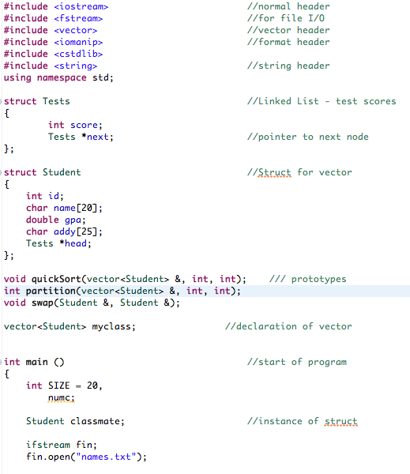

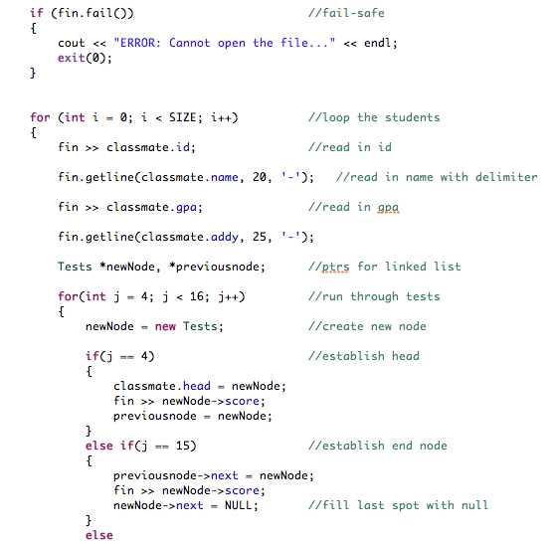

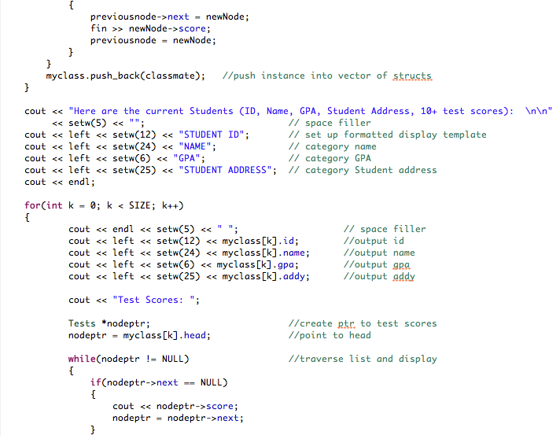

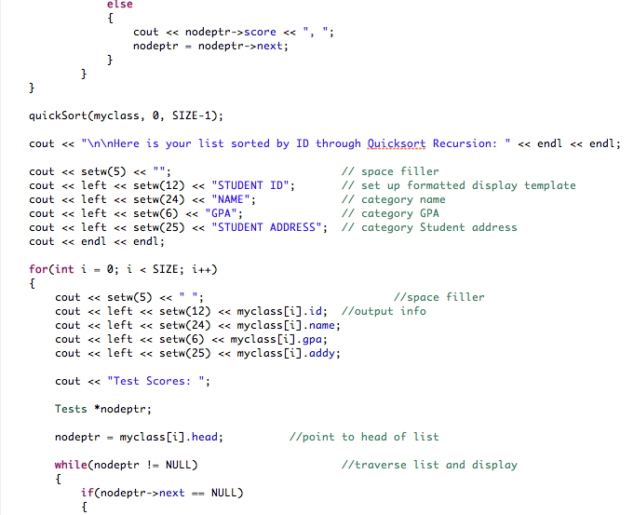

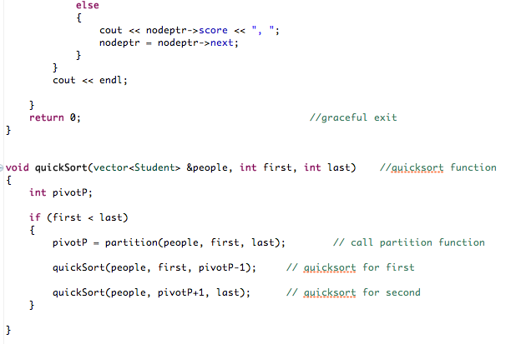

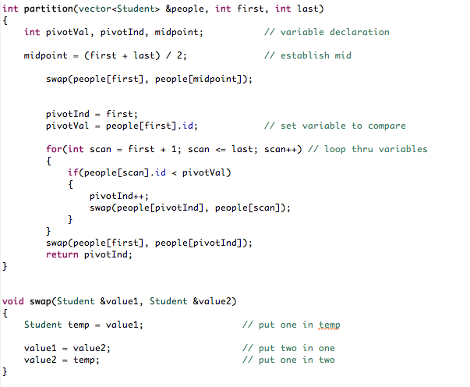

**Names.txt**

